
Worldwide Customer Services
Embedding WebFOCUS in a Python Web Application
WF8206
August 2019

CONTENTS
Contents
CONTENTS 2
EXECUTIVE SUMMARY 4
Roles 4
Application Overview 5
Setting Up Our Flask Application 6
Authentication: Sign On and Sign Off 8
Sign On Steps 8
wfrs.py – Session Object 9
Session Object Initialization 10
Session Object Sign On 11
Session Object Sign Off 13
app.py - WebFOCUS Authentication in our Flask Application 14
Sign On 14
Sign Off 17
Making Requests 17
List Files in WebFOCUS Path 19
Listing Files from a Path Steps 19
app.py – List Files in Path 19
Get Files in Path as XML Response 19
Create Python List of File Names from XML Response 22
HTML & Jinja2 – Creating a Dropdown of Report Names 22
Run WebFOCUS Report 25
ReportCaster Schedules 26
Running a ReportCaster Schedule 26
Creating a Simple Table of Schedules 27
Get Schedule Info and Log 35
Schedule Info and Log Retrieval Steps 36
Submitting Schedule Name 36
Retrieving Schedule Information 38
Run Report Deferred 42
View and Use Deferred Tickets 43
Delete Item 44
CONCLUSION 45

EXECUTIVE SUMMARY

This document walks through a sample web application that allows an end user to utilize WebFOCUS features without directly using the WebFOCUS client. The web application, written in Python using the Flask framework, interacts with WebFOCUS using RESTful service calls and displays the information to the user.
The Python application allows the user to interact with three major features of WebFOCUS: running reports directly, running a report deferred, and running a report schedule via ReportCaster.

Roles

These are the contributors and support resources who helped us deliver this project.
Worldwide Customer Services

Name | Title

Other Information Builders Resources

Name | Department | Title

Application Overview
This application uses the Python Flask web framework to create a web server. The server interacts with end users via its front end, and interacts with WebFOCUS through REST calls in its back end.
The Flask app will use the third-party Python Requests library for its Session object, which will be used to make HTTP requests to WebFOCUS RESTful services.
This document assumes some prior knowledge of REST, Python, requests, and Flask.
In particular, it is important to know the basics of how a Flask application processes a request it receives, and how to utilize he requests library to create a request and process its response.
Most importantly, application and requests contexts for flask are used in the design decisions for this application, so you may find more information in Flask’s documentation, found here: https://flask.palletsprojects.com/en/1.1.x/
We will use a single file for our Flask application, app.py, in the directory Embedded_WF. The Embedded_WF directory will contain a folder called Templates where our html code will be.
We will also create a wfrs.py file to store the independent WF_Session class we will create to initialize webfocus requests, which will be imported into app.py.
Our templates will be rendered in Flask via the jinja2 templating language; this allows rendering of variables into a static html to be sent to a client. So for example if we want to create a static html table of a schedule’s log, we can use jinja2 in the .html file and pass in Python variables through Flask, where they will be properly rendered. This avoids the pain of rendering html as strings through Python.

Setting Up Our Flask Application
Flask is a web server microframework, so it is easy to get set up. It is strongly recommended to follow the official Flask tutorial first if you do not have experience with Flask.
We will store all of our Flask code in the ‘app.py’ file.
Initially, it should look like:

A production Flask application should include better security and precautions, but for this sample, the focus is on interacting with WebFOCUS in the backend. Most of these variables should be set up as environment variables or inside a config file.
We will be importing many libraries later in this application, but for now all we need is flask.
Ibi_client variables will relate to the WebFOCUS client we are interacting with. It does NOT need to be on the same host or port as this Flask application, but the server the Flask app runs on must be able to access the WebFOCUS client.

Since we have a flask application, we can use its features to our advantage when embedding WebFOCUS.
In Flask, the concept of contexts is fundamental to designing the application. Variables do not persist between requests, sessions, and application creation unless specifically requested to, and even then there are limitations.
In particular, Flask has a ‘g’ object, which is created when the application is initialized to receive a request, and a ‘session’ object, which is a dictionary based on the session cookie, containing JSON serializable variables (distinct from the requests.Session or our WF_Session object. Please read the official Flask documentation to better understand this.
We will use these often, as you will see in the Authentication section.

Authentication: Sign On and Sign Off
Before we can embed WebFOCUS in our application, we need to understand how to make authenticated requests to WebFOCUS.
This section will show the Python code generating requests made to sign on the current application to WebFOCUS.

Sign On Steps

Sign on involves:

- Making the request to sign on via WebFOCUS REST
- Confirming sign on was successful
- Saving the WF-JSESSIONID cookie from the HTTP response and saving the CSRF Token generated in the XML response body

To do these steps, we will use the Python Requests module, specifically the session object from this to store the WF-JSESSSIONID cookie and CSRF Token for future requests.

wfrs.py – Session Object

Session Object Initialization
In a file called wfrs.py, we will initialize a Session object which inherits from requests.Session. It will have additional functionality to sign on to WebFOCUS, sign off from WebFOCUS, and save the CSRF Token to be used in other WebFOCUS requests.

We must initialize the parent requests.Session object in our __init__ method.

The “self.IBIWF_SES_AUTH_TOKEN = None” line is a placeholder for the instance’s CSRF Token, which will be retrieved after we sign in.

Now, we can use this object to sign on.

Session Object Sign On
We can create a method in our WF_Session object, mr_sign_on, which signs in to WebFOCUS using a REST call.
It takes the protocol, host, port, userid, and password as parameters, then sends the request using these values.
The response will contain an XML of whether the connection was established, or if there was an error in the login.
This method parses the XML response to find the CSRF token, then saves it to the WF_Session object’s IBIWF_SES_AUTH_TOKEN attribute.
We use the xml.etree.ElementTree library to parse the XML response. To do this, we need to add another import statement at the top of our wfrs.py file:
The code for _save_ibi_csrf_token is as follows:
It assumes friendly user input so we can improve this by adding try/except blocks, and returning a bool True/False to let mr_sign_on know if it was successful.

When a WF_Session instance is created and the mr_sign_on method is called with valid parameters, the instance should automatically set the proper WF-JSESSIONID cookie to successfully make future requests to WebFOCUS.

Session Object Sign Off
When a sign off call is made to WebFOCUS, the current WF-JSESSIONID will be invalidated, so no requests can be made without signing in again.
For security purposes, we will eventually sign off of WebFOCUS every time we sign in, after we finish making requests.
Our WF_Session object’s WF-JSESSIONID cookie will be automatically invalidated and then set to a new, random value by the WebFOCUS client server. However, our CSRF Token was stored in the instance so it must be set to None.
The code for mr_signoff is as follows:

app.py - WebFOCUS Authentication in our Flask Application

Sign On
Now, we have Python code to interact and authenticate with WebFOCUS in the form of a WF_Session object and mr_sign_on and mr_signoff method definitions.
However, these exist in the ‘wfrs.py’ file. If it is located in the same directory as ‘app.py’, where our Flask app exists, we can import it through the statement:
import wfrs
In app.py, we will use the ‘g’ object to store a WF_Session instance for a request. This way, if we connect to WebFOCUS to process a user request, we can control how the WF_Session will be used between functions in our application. We only need to instantiate one WF_Session and sign on once to process every request to WebFOCUS we need to, before signing out and destroying the connection.
To do this, we can create a wf_login function to retrieve the WF_Session, creating an instance if it does not already exist or retrieve an already existing instance.
We call the wf_login function in every Flask route and view where we need to connect to WebFOCUS, such as when retrieving a report or listing files in a path.

The wf_login function is as follows:
We define the key for our WF_Session instance in ‘g’ to be ‘wf_sess’, so we can retrieve the instance via dot notation (g.wf_sess) or through other dictionary methods such as g[‘wf_sess’], g.get[‘wf_sess’].
The default credentials will be username: admin, password: admin.
It is recommended to create a service account or utilize a different method of Single Sign-On such as trusted ticket if those options are available to you.

Sign Off
Without any other code, the Flask g object and our WF_Session instance with it will be destroyed after the request is processed and a view is returned. We wish to sign off before it is destroyed for security purposes, so to do that we use a Flask decorator:

The @app.teardown_appcontext decorator before the defined function tells the Flask app that this function should be called right before it destroys the app context (‘g’).
We retrieve our instance of the wf_sess and remove it from the ‘g’ dictionary, if it exists.
If it does not, there is no need to sign out; otherwise, we call the mr_signoff method.
The error parameter is passed in by Flask when this function is called, so that we can adapt our function to any errors processing the request. However, we always want to sign out of WebFOCUS when the request is finished regardless of if there was an error or not, so we do not use it in the function.

Making Requests
To interact with WebFOCUS in our Flask application, we can now just use a simple flow of:
- Call the wf_login() function and assign the session to a variable (we use wf_sess)
- Prepare request url, parameters, payload using proper REST calls
- Make the request
- Parse the response
- Pass relevant data to the front-end html template

An important step to note is that when a POST request to WebFOCUS is made, such as to delete an item, the CSRF token must be included in the payload.
Our WF_Session object inherits from the Requests Session object, so when given a dictionary of key value pairs as a “data” parameter, the body will be properly formatted accordingly. This makes including a CSRF token easy.
An example code snippet to delete an item within a Flask app route:
If there exists an item named “Report1.fex” in the public repository, it will be deleted via this REST call.

Note: From now on, we will be working within app.py always.

List Files in WebFOCUS Path
Before we can access any files in WebFOCUS, we need to retrieve a way to identify and call them. WebFOCUS Repository items follow unique file paths which we can use.
In this sample application, we assume all report and schedule files will be under the public repository, “WFC/Repository/Public”, which is why we initialized ibi_default_folder_path to this when we created our Flask app.
If a stronger use case is required, the steps in this section can be extended to recurse on folders within repositories, but this will be not covered.

Listing Files from a Path Steps

- Making the request to list files in the specified path
- Parsing XML response

app.py – List Files in Path

Get Files in Path as XML Response
When the proper call is made, WebFOCUS will return an XML response object. If it’s a success, the parent node will be an IBRSResponseObject. The rootObject is one of its children, and what we are interested in.
The rootObject will contain all files in the path as children with the respective object type as a tag. For example, schedules will be tagged as “casterObject”, and reports will be tagged as “FexFile”.
The Python code to retrieve the rootObject xml as an ET root node is:

From the parent response object, we retrieve the rootObject as files_xml.
We can further parse this rootObject and only return XML children of files of the type which we desire.
The following code extends the function to list all the files of a certain file_type in this directory:
If the function is called with no file_type selected, it will default to including all files.

Create Python List of File Names from XML Response
The XML Tree object is hard to use in Python code, so we would like to parse and extract its information into a more easily usable data structure. We will generate a list of the item names in the selected path (with the selected file type if needed) for easier use in our Flask app.
The following function will take in the rootObject created above (parent directory) and return a list of the item names of its children (files in the directory):

HTML & Jinja2 – Creating a Dropdown of Report Names

Using Flask’s render_template function, we can pass in the name of an html template that is in the Templates directory. The Templates directory itself should be in the same directory as our WebFOCUS app.
In the next section, we will provide an interface for users to view WebFOCUS reports, using the /run_reports route. So if our app is hosted on ‘http://localhost:5000’, users can navigate to ‘http://localhost:5000/run_reports’ via any means and access this page.
We will call the html template for this page ‘run_reports.html’. It will contain jinja2 syntax to dynamically generate a static html page.
On this page, we will create a select dropdown of report names for the user to select.
The HTML + jinja2 code for this looks as follows:
The form will submit the option selected as a post request to ‘http://localhost:5000/run_report’. The html tag “name” determines the key of the request, and “value” determines its value, which we will use to receive and process in Flask.
The Flask route ‘/run_report’ must process the request and return a proper html response to be displayed in the iframe.
However, first we must render this template under the ‘/run_reports’ route, so that this interface is accessible. This can be done with the following code in app.py:

Using the functions we coded above, we send a list of report names to the jinja2 templating in ‘run_reports.html’. In the html code we see:
{% for rep_name in reports %}
<option value="{{rep_name}}">{{rep_name}}</option>
{% endfor %}

So jinja2 will loop through the Python variable ‘reports’ that we passed in, which is a list of report names.
It will create an option for the select dropdown with name and value for each report name.
The html page when rendered on ‘http://localhost:5000/run_reports’ will look like:
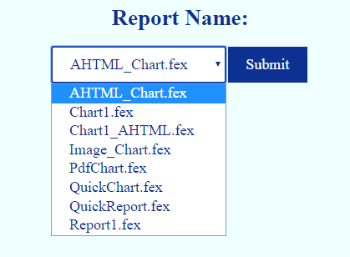

In the next section, we will go through the process of receiving this report name when it is submitted and running the associated WebFOCUS report.

Run WebFOCUS Report

ReportCaster Schedules
Running a ReportCaster schedule is very similar to running a report, but is in fact much easier. The response will return a ‘200’ status code and an html of schedule job id upon success,
or a ‘404’ status code with xml of failure response code if not.
To make using schedules easier, we will expand upon the List Files in Path function for ReportCaster schedules to create a schedule table with more detail beyond just schedule name.

Running a ReportCaster Schedule
Similar to the Run Report section, we will create a ‘/run_schedule’ route to run the schedule.
The Python Flask code to do so is as follows:

We will flash a message to the user depending on the success of running the schedule. For this app, return redirect(request.referrer) will take the user back to the schedules page when the schedule is run.
We will have two schedule pages: a simple version with a dropdown of schedule pages like ‘run_reports’, and a more detailed table of schedule information, but with the same features. The request.referrer will take the user back to whichever version they initiated the request with.

Creating a Simple Table of Schedules

We can easily replicate the ‘/run_reports’ page into a ‘/schedules’ page that does equivalent functionality:
app.py:
schedules.html:
The jinja2 segment at the end displays the flashed message based on the response of our form submission to run a schedule.
However, we additionally give users the option to view a full table of contents of the schedules, and add the option of viewing its information and log in a new page. Before we cover how to create these features, this is how the page would look when rendered:

http://localhost:8080/schedules :

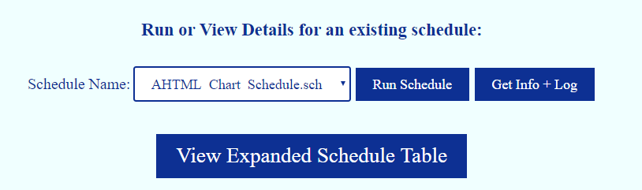

When the “View Expanded Schedule Table” button is clicked, it submits a get request with the “expand” key set to “View+Expanded+Schedule+Table”.
We must process this in Flask. Our new ‘/schedules’ route will look like:

app.py:
We loop through all the schedule objects in the xml response and receive all relevant details, storing them into a dictionary. Because the time values WebFOCUS uses are unixtime in ms, we must convert them into human readable datetime format. We will use this again in a later section, so we create a separate function to handle this:
Currently, only schedules with email destinations are supported.
To expand the functionality, a separate function to parse xml into a formatted list or dictionary should be created, which properly adapts to the destination type. However, this is an exercise in parsing xml in Python, so it will not be included in this document. XML schedule format can be found in the REST WebFOCUS documentation, included in the appendix.
The schedule_items_list that is passed to the template is sorted by most to least recent creation time. We use a list instead of a dictionary to preserve the sorted order, and for simplicity; there are other possible data structures that are optimal for this usage like an ordered dictionary.
Our new ‘schedules.html’ file will look like:

Note: Our table headers are just the keys of the dictionary we created so we could potentially create a headers list and pass that in to generate the table headers.
Also note that the form actions and options for each table row remains the same as from the original dropdown.
The schedules table at http://localhost:5000/schedules?expand=View+Expanded+Schedule+Table will look like:
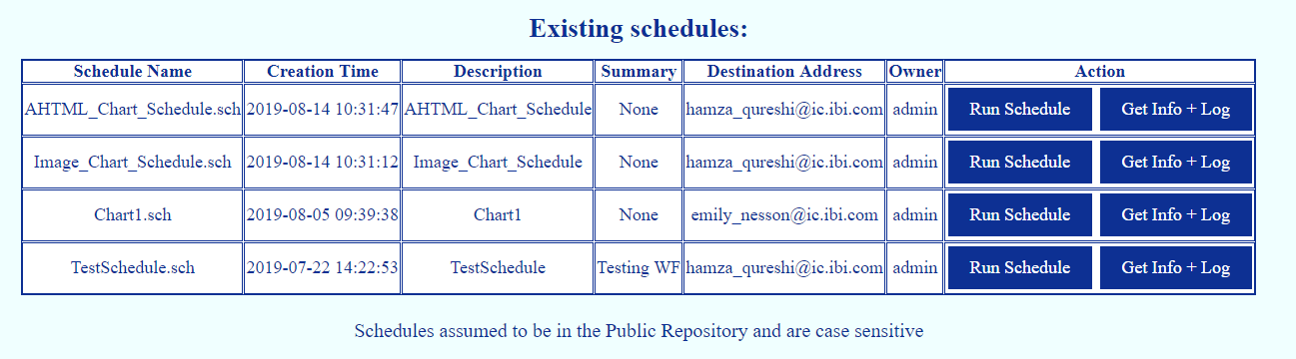

Selecting “Run Schedule” and receiving a valid success response from WebFOCUS will give the user the following message:
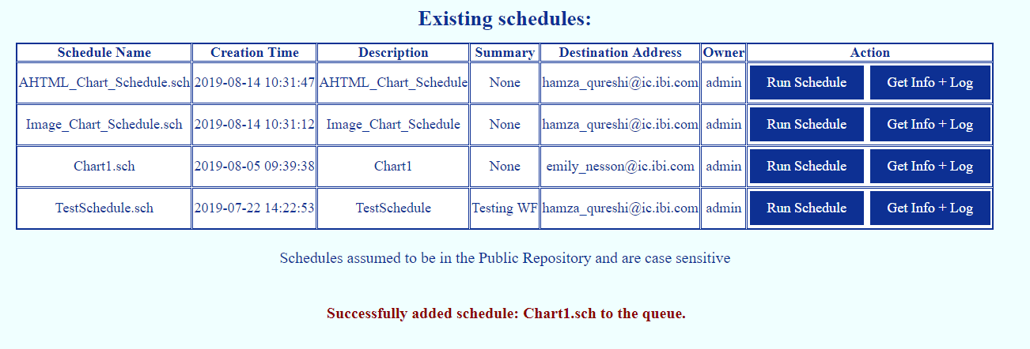

Selecting “Get Info + Log” will be covered in the next section; it will display a page with tables of more detailed information and logs for the selected schedule.

Get Schedule Info and Log
A schedule id can be used to retrieve log information about its run history. On WebFOCUS, this can be found on the ReportCaster Status page and looks like:
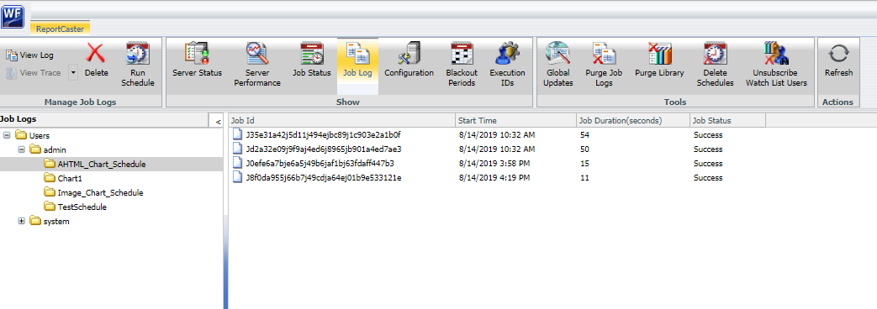
The jobs on WebFOCUS can be clicked on to receive a more detailed description of the job-specific log. For our application, however, we will only provide basic schedule and log information akin to what is shown above. The final table will look like:

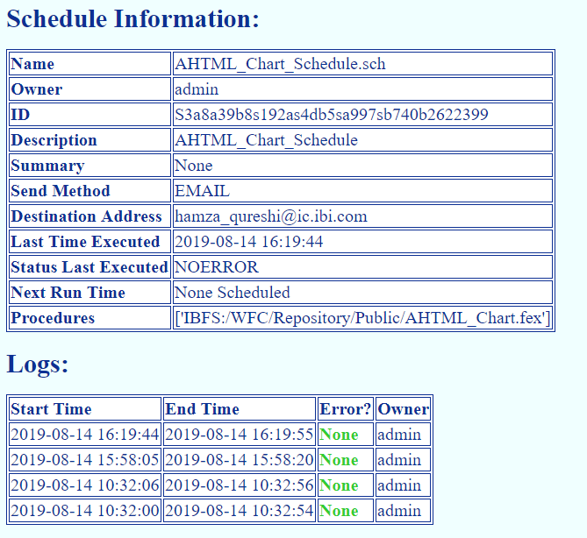

Schedule Info and Log Retrieval Steps
- Get Schedule name and file path. This will be done via form from the front end schedule page.
- Get info about the schedule file from the standard WebFOCUS REST service. This will contain the information in the first table, most significantly the schedule id.
- Use the schedule id to get log information via WebFOCUS Log Service REST.
- Display information in human readable format.

Submitting Schedule Name
Getting schedule name and path is the same as in the other section where we used these variables to run it. The first part of our “/view_schedule_log” route will look like:

(Note: all Python code in the remainder of this section will live under this “/view_schedule_log” route.)

The associated HTML code will look like:

And when rendered will look like:
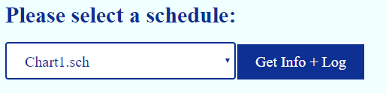

This is basically the same as the “/schedules” route with only the option of getting info and log.

Our Flask application will pass in the schedules list only if no schedule is selected; otherwise, it will pass in the schedule name (as “schedule”) since we will only be considering one schedule on this page.

When a schedule name is passed in, we can split the view schedule log route into two parts: retrieving the schedule information, and retrieving the schedule log.

Retrieving Schedule Information
To receive information about a file via WebFOCUS REST services, we use the IBIRS_action of get using the ibfs service. This will return an XML object with the object as a child tag of the rootObject. We know what type of object it will be based on the extension of the file; in our case, it will be a CasterObject.

To check if the file entered is valid, we need to check if the IBFS response object’s status code is 10000 which indicates a success. A different response code indicates failure, and will break our XML parsing attempt.

The Python code to do this will look like:
If the schedule is not listed, the very simple HTML will include the given text and a link to return to the main schedules page:

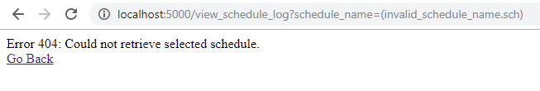

Otherwise, we will need to parse the XML.
The rootObject will be a child of the IBFS Response object and will contain the schedule id, which we will need for the schedule log section.
The casterObject will contain all other relevant information, and will be a child of the rootObject.
From the casterObject XML, in this app we will parse for:
Schedule Name, Owner, ID, Description, Summary, Send Method, Destination Address, Last Time Executed, Status Last Executed, Next Run Time, and Procedures.

The rest of the given code is an exercise in parsing this XML so it is given below:

We stored this schedule information in a simple dictionary because in our web page, we will have a simple two-column table with the key-value pairs for each attribute.
The Jinja2 and HTML code to parse through this dictionary looks like:

And the rendered web page will look like:

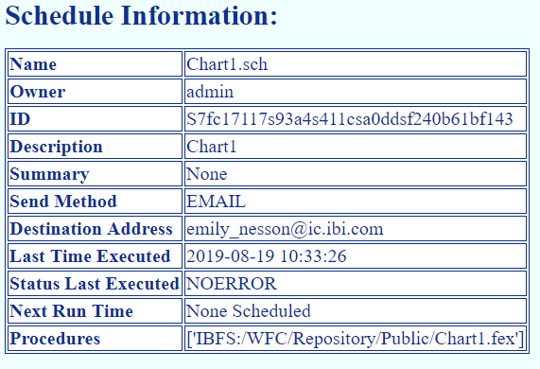

Now, we will use the schedule ID to retrieve its logs.

Retrieving Schedule Job Log
The format of WebFOCUS Log REST responses is different from the normal IBFS REST service in that it uses namespaces, which makes parsing a bit more involved. However, the general concepts are the same.

We will make the REST call to the LogServiceREST url, then parse the XML response and attributes to create human readable values to use in our table.

The code to make the call and receive a response is as follows:

# Have schedule id, now use it to retrieve log list
url = f"{ibi_client_protocol}://{ibi_client_host}:{ibi_client_port}" + \
"/ibi_apps/services/LogServiceREST/getLogInfoListByScheduleId"

params = dict()
params['scheduleId'] = schedule_id

log_response = wf_sess.get(url, params=params)
if log_response.status_code != 200:
error = f"Could not receive log data for {schedule_name}"
return render_template('schedule_log_info.html', schedule=schedule
error=error)

If the schedule has no log data response, we will only display the information we collected above. We add to the html code:

Otherwise, we will parse the log data xml response and display it in a table.

An example of a LogServiceREST xml response looks like:

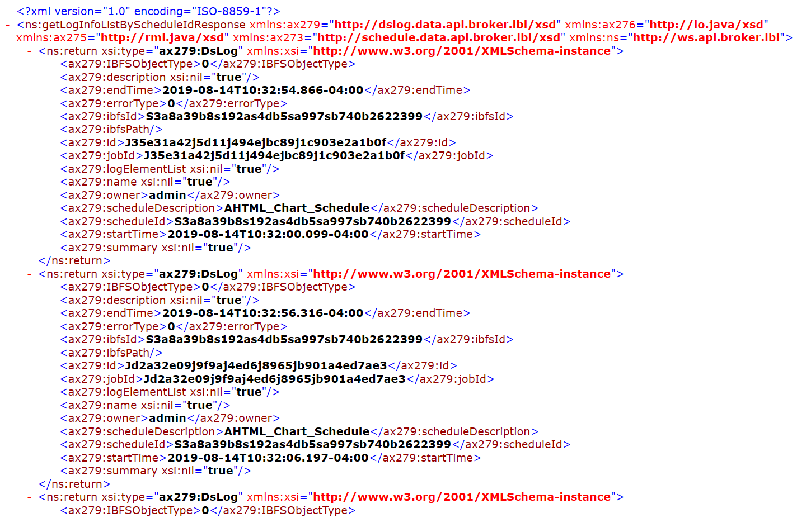
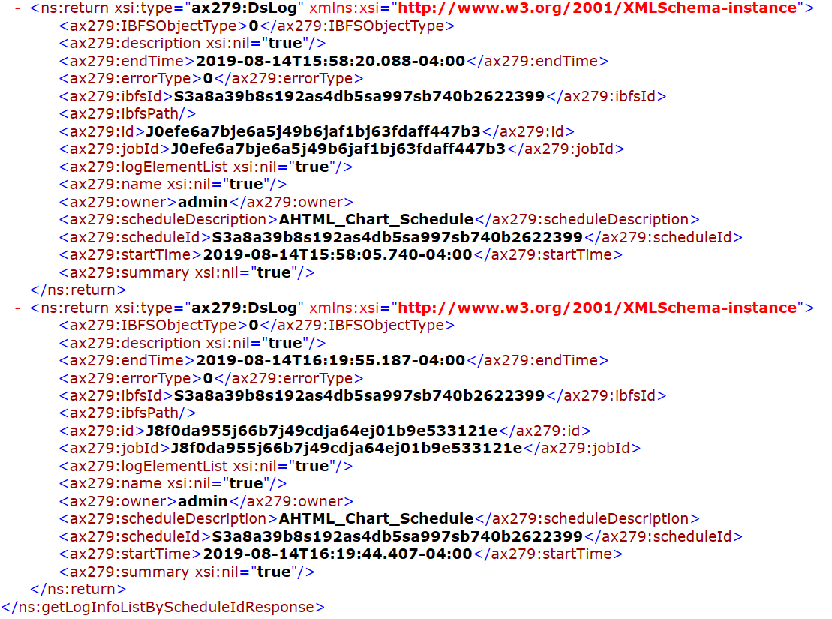

The Python ET library will by default resolve namespace tags in the form of “{url}tag”, so when working with this XML, we will need to split by ‘}’ to get the tag.

Most of the Python code below will deal with formatting time and error type into meaningful values using a string formatter function dictionary. For each job/log item, we will output the data to a dictionary. This dictionary will be stored in a list of log_item dictionaries, which will be sorted by creation time, to be used in creating the HTML table output.

The code is as follows:

To process this in the HTML, we use the following code:
The styling for errorType simply adjusts the color between green, orange, and red depending on the status.
Here is an example of what this would look like when rendered:
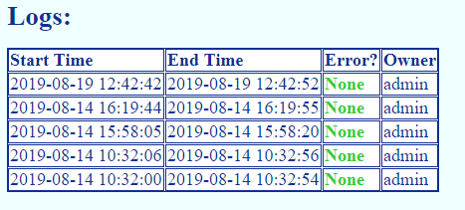

This is all we will do with logs for this sample application. However, there are other Log service REST calls we can make, such as retrieving the full log for a specific job. Python allows us to be creative in how we use and make these calls, such as providing a new link for such information only if there is an error.

Run Report Deferred

View and Use Deferred Tickets

Delete Item

CONCLUSION
[Describe the conclusion here. Use any format that you think will best represent your conclusion.]

